HR KPIs Dashboard User Guide

This guide walks users through the HR KPIs Dashboard, explaining each visual component and what it represents. Use this dashboard to gain insights into contractor reporting, hours worked, work product statuses, and labor category distributions.

# Contractors with Zero Submissions

This section highlights any contractors who have not submitted their reports for the reporting period. This ensures accountability and prompt follow-up.

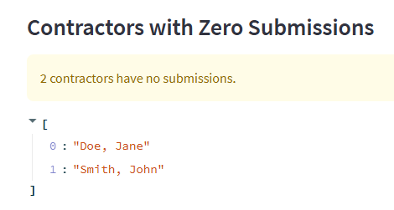

# Monthly Hours Heatmap by Contractor

This heatmap provides a detailed view of hours logged by each contractor over time, helping to identify work patterns and engagement levels.

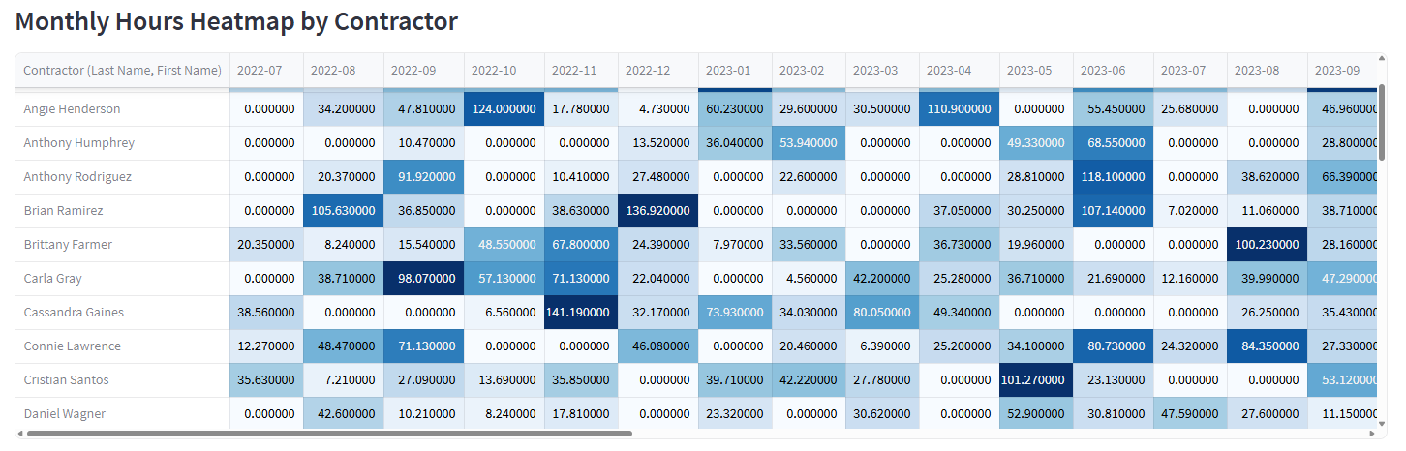

# Labor Category Distribution

The pie chart breaks down the contractor workforce into categories such as Developer, Engineer, Manager, and Analyst, giving insight into workforce composition.

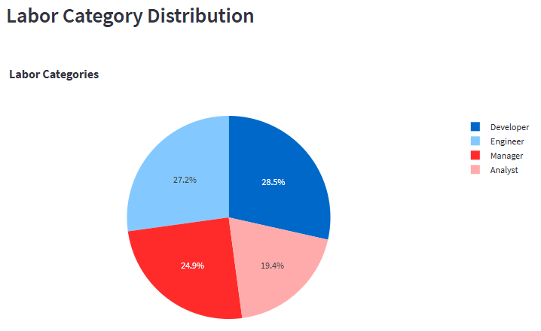

# Top Work Products by Total Hours

This table ranks the work products with the highest logged hours, helping management identify where the most time is being spent.

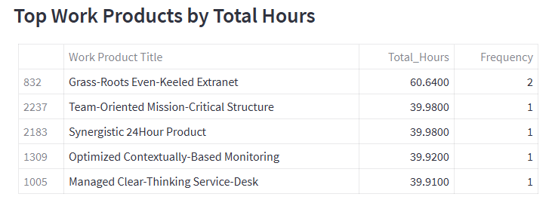

# Unplanned Hours by Division

A bar chart showing the total number of hours worked on unplanned tasks, segmented by division. Helps highlight workload predictability.

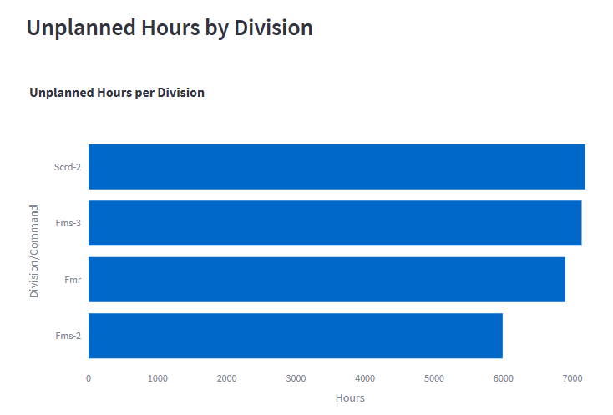

# Level of Effort by Division

Displays the percentage of total effort (in hours) contributed by each division. Useful for comparing division-level workload.

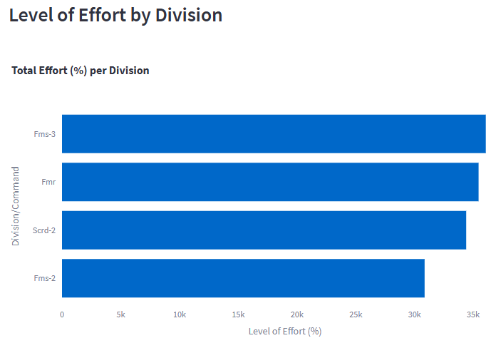

# Weekly Completion Trend

A line chart showing weekly trends of work products completed, on hold, or in progress. Useful for tracking project velocity and progress over time.

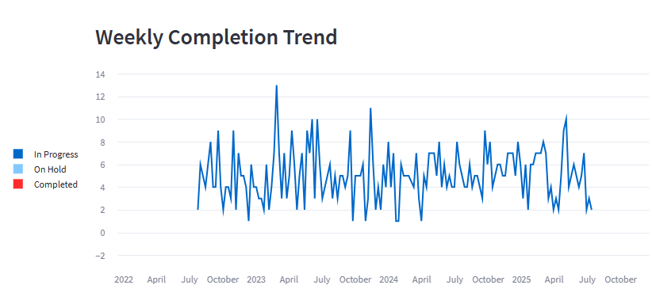

# Work Product Status Overview

Pie chart showing distribution of work products across statuses: Completed, In Progress, and On Hold.

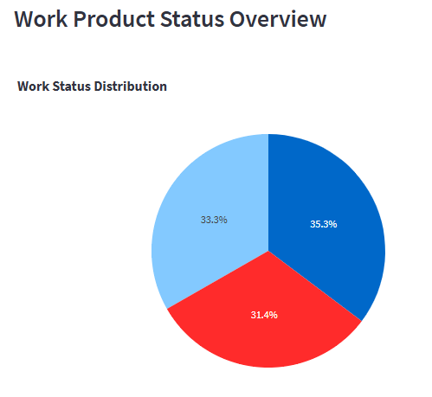

# Key Performance Indicators

A snapshot view of total hours worked, average hours per contractor, percent of unplanned hours, and count of non-reporting contractors.

